|  |  |
| --- | --- |
| **Name :-** | Aryan Dilipbhai Langhanoja |
| **Enroll No: -** | 92200133030 |

## Universal NAND gate and its application in level monitoring in chemical plant

* **Aim** :-

The aim of the experiment is to apply NAND gate logic in a level monitoring system in a chemical plant. Using generalized simulator framework, the user will be able to place a NAND gate, make input-output connections and verify its truth table.

* 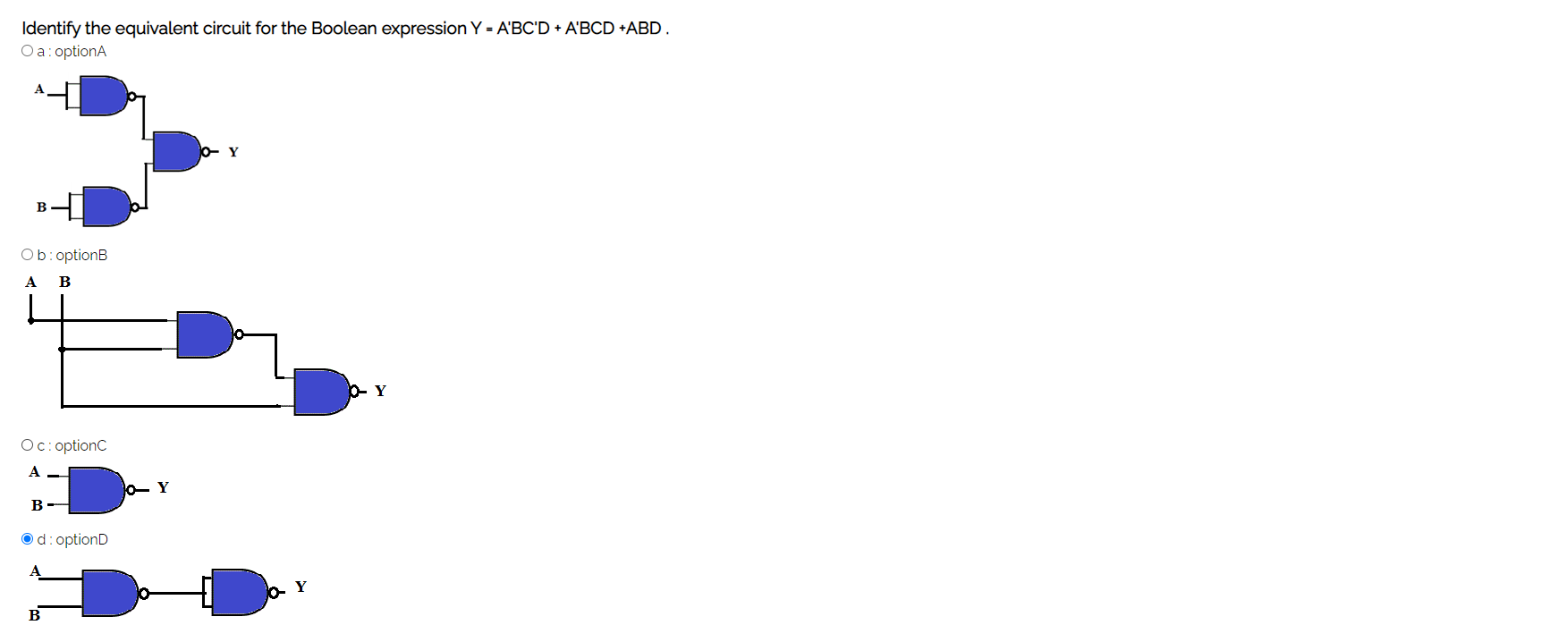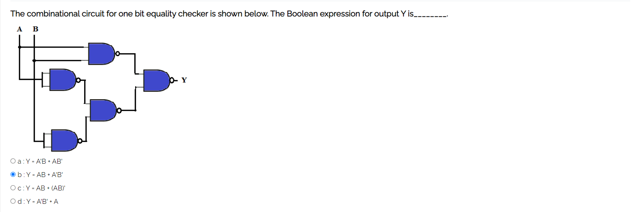**Pre-test :-**

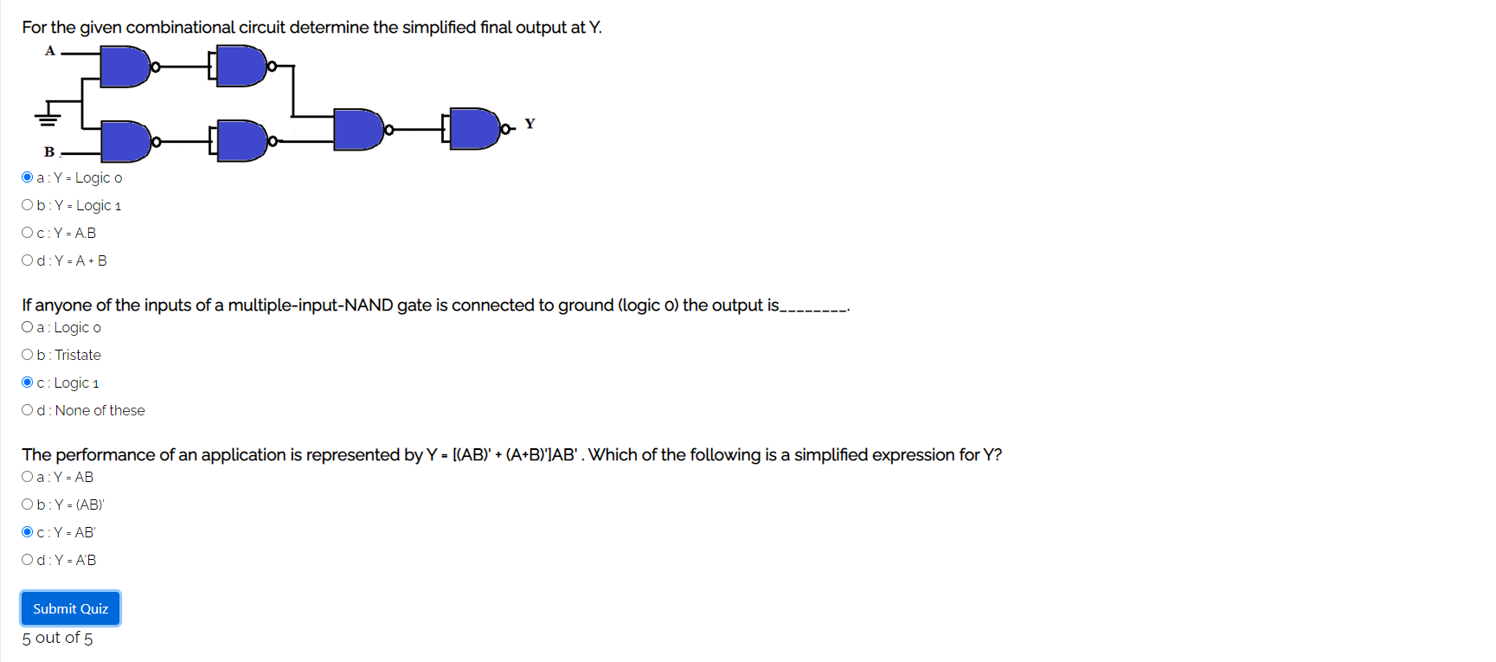

* **Simulation :-**

**Task:-** Build OR gate logic using only NAND gates and verify its working.

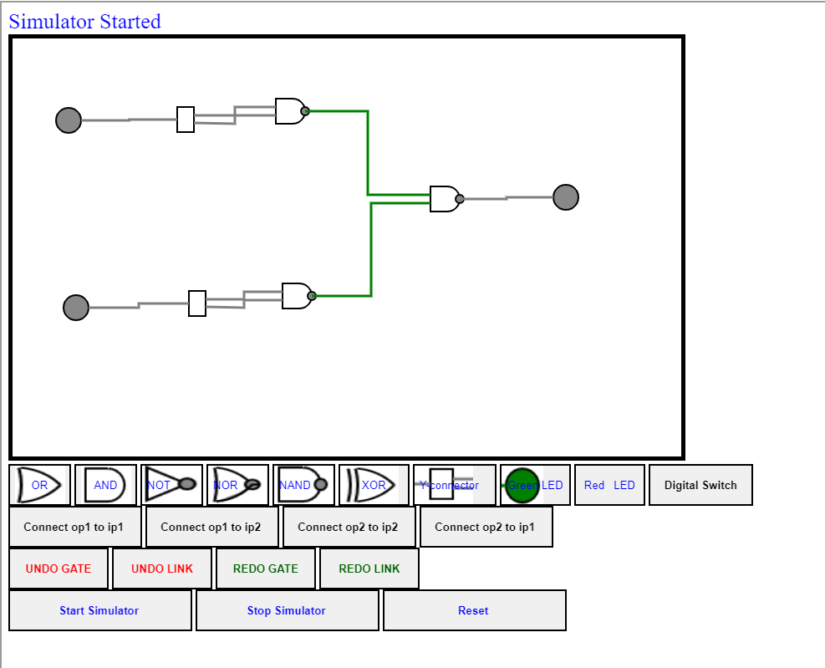

* **Post-test :-**

